

Dr. Katherine, Sherman inc.

2015-03-31

Dr. Sherman

USS Ellis, FPO AP 41955

Phone: 4705532698

Fax: 6975705367

**Re:** Alyssa, Wong

**PHN:** 8618405320

**Birthdate:** 20-Sep-1957

**Address:** 78650 Kimberly Shores, Lake Michael, AZ 60805

**Patient number:** 880391733

To Whom It May Concern:

This is a medical letter to state the above patient is pregnant with expected delivery date of 23-Apr-2025. Hoping this information is satisfactory for your requirements.

Thank you.

Sincerely,

Dr. Katherine, Sherman

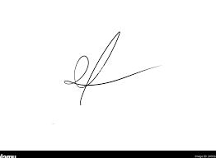

FRCS© NCMP

Clinical Assistant Professor, UBC

Department of Obstetrics and Gynecology SMH